SEND Policy
February 2023
This policy complies with the statutory requirement laid out in the SEND Code of Practice (July 2014) and has been written with reference to the following guidance documents:
- Equality Act 2010: Advice for schools DfE (Feb 2014)
- Schools SEN Information Report Regulations (2014)
Our aims for SEND pupils:
- To ensure that all pupils have access to a broad and balanced curriculum.
- To provide a differentiated curriculum appropriate to the individual’s needs and ability.
- To ensure the identification of all pupils requiring SEND provision as early as possible in their school career.
- To ensure that SEND pupils take as full a part as possible in all school activities.
- To ensure that parents of SEND pupils are kept fully informed of their child’s progress and attainment.
- To create an environment where pupils can contribute to their own learning, where they feel safe and listened to.
- To ensure that all pupils have access to a broad and balanced curriculum, including extra curricular activities. Pupils with SEND are actively encouraged to participate in a number of activities aimed to improve gross motor, physical and social development alongside extra learning opportunities. We offer extra curricular clubs which include Outdoor Sports, Sewing, Art, Music, Yoga, Gardening and Cooking.
We recognise that many pupils will have special needs at some time during their school life. In implementing this policy, we believe pupils will be helped to overcome their difficulties.
Whilst many factors contribute to the range of difficulties experienced by some children, we believe that much can be done to overcome them by parents, teachers and pupils working together.
Definition of Special Educational Needs
‘A child or young person has SEN if they have a learning difficulty or disability which calls for special educational provision to be made for him or her’ (SEN Code of Practice July 2014).
Special educational provision means:
‘Educational provision that is additional to or different from that made generally for other children or young people of the same age by mainstream schools’ (SEN Code of Practice July 2014)
A child has learning difficulties if he or she:
- Has a significantly greater difficulty in learning than the majority of children of the same age.
- Has a disability which prevents or hinders the child from making use of educational facilities of a kind provided for children of the same age in other schools within the Local Authority.

Children must not be regarded as having learning difficulties solely because their language, or form of the home language, is different from that in which they are taught.
Hove Micro-School will have due regard for the Special Needs Code of Practice 2014 when carrying out our duties towards all pupils with special educational needs and ensure that parents are notified when SEND provision is being made for their child.
At our school we provide support for children with a range of special educational needs. Special educational needs could mean that a child has difficulties in:
- Communication and Interaction - In expressing themselves or understanding what others are saying
- Cognition and Learning - In acquiring basic skills in school
- Social and Emotional Mental Health - making friends or relating to adults or behaving properly in school
- Sensory and/or Physical - such as hearing or visual impairment, which might affect them in school or medical or health conditions which may slow down a child’s progress and/or involves treatment that affects his or her education.
Children make progress at different rates and have different ways they learn best. Teachers take account of this when they plan teaching and learning activities. Children making slower progress or having particular difficulties in one area may be given extra help/support or different lessons to help them succeed.
Admissions
The admission arrangements for all pupils are in accordance with national legislation, including the Equality Act 2010. The school does not discriminate against pupils with SEND and all applications will be considered on a case by case basis.
Inclusion
This policy builds on our Curriculum Policy which recognises the entitlement of all pupils to a balanced, broadly based curriculum. Our SEND policy reinforces the need for teaching that is fully inclusive. The Head of School will ensure that appropriate provision will be made for all pupils with SEND.
The Head of School ensures that resources are allocated to support appropriate provision for all pupils, within budget constraints.
Identification
At Hove Micro-School we have adopted a whole- school approach to SEND policy and practice. All staff are committed to the principles and aims of this policy. Pupils identified as having SEND are, as far as is practicable, fully integrated into mainstream classes. Every effort is made to ensure that they have full access to our child-led curriculum and are integrated into all aspects of the school.
All teachers are responsible for identifying pupils with SEND and, in collaboration with the SENCo, will ensure that those pupils requiring different or additional support are identified at an early stage. Assessment is the process by which pupils with SEND can be identified. Whether or not a pupil is making progress is seen as a significant factor in considering the need for SEND provision.
Early identification of pupils with SEND is a priority. The school will use appropriate screening and assessment tools, and ascertain pupil progress through evidence obtained by teacher observations/ assessments. See our Assessment Policy for more detail.
The SEN Code of Practice (2014) suggests that pupils are only identified as SEN if they do not make adequate progress once they have had all the intervention/adjustments and good quality personalised teaching. Our teachers use their own assessments and observations to produce differentiated planning in the first instance. Quality first teaching enables teachers to both identify and support children with special educational needs through thorough assessment and differentiation of tasks and support.
The school’s system for regularly observing, assessing and recording the progress of all children is used to identify children who are not progressing satisfactorily and who may have additional needs.
Class teachers will make regular assessments of progress for all pupils and identify those whose progress:
- Is significantly slower than that of their peers starting from the same baseline
- Fails to match or better the child’s previous rate of progress
- Fails to close the attainment gap between the child and their peers
- Widens the attainment gap
This may include progress in areas other than attainment, for example, social needs. Slow progress and low attainment will not automatically mean a pupil is recorded as having SEND. When deciding whether special educational provision is required, we will start with the desired outcomes, including the expected progress and attainment, and the views and the wishes of the pupil and their parents. We will use this to determine the support that is needed and whether we can provide it by adapting our core offer, or whether something different or additional is needed.
Code of practice graduated response
The school adopts the levels of intervention as described in the SEND Code of Practice.
The Code of Practice advocates a graduated response to meeting pupils’ needs.
SEND Monitoring
•Any pupils who are falling outside of the range of expected academic progress will be monitored and assessments will be made as described above to determine if further intervention is required.
•The class teacher will take steps to further differentiate the learning to better support the pupil and this may require an adjustment in the style of teaching adopted with that pupil.
•The SENCo should be informed and consulted to provide support and advice and may wish to observe the pupil.
•Parents will be fully informed so they can share information and knowledge with the school to help better understand the needs of the child.
•The child is recorded as being monitored; this does not mean they will automatically be placed on the SEND register.
SEND support
When it is determined that a pupil does have SEND, parents will be formally advised of this and the decision to add the pupil to the SEND register is made. The aim of formally identifying a pupil with SEND is to help the school ensure that effective provision is put in place and so remove any barriers to learning.
There are two levels of SEND support; targeted supported and specialist support. Targeted support is initiated when a child or young person has received quality first teaching (QFT) but has not made expected progress and requires additional support in school. The adaptations and additions that are made as part of targeted support are internal to the school. If targeted support is not sufficient to meet the child or young person’s needs they will require specialist support involving external agencies.
All levels of support consist of a four part process: Assess, Plan, Do, Review.
This is an ongoing cycle to enable the provision to be refined and revised as the understanding of the needs of the pupil grows. This cycle enables identification of those interventions which are most effective in supporting the pupil to achieve good levels of progress and outcomes.
Looked after children who are identified with SEND will follow the procedure as above (Assess, plan, Do, Review), social care and foster carers will be invited to the meeting.
Assess
This involves clearly analysing the pupil’s need using the class teachers’ assessment and experience of working with the pupil, details of previous progress and attainment, comparisons with peers and national data, as well as the views and experience of the parents. Advice from external support services and staff will be sought if appropriate and with the agreement of the parents.
Plan
Planning will involve consultation between the teacher, SENCO and parents to agree the adjustments, interventions and support that are required; the impact on progress, development and/ or behaviour that is expected and a clear date for review. Parental involvement may be sought, where appropriate, to reinforce or contribute to progress at home. This plan with be recorded in the form of a Target Planning and Reviewing document which will be shared with staff, parents and the pupil.
Do
The class teacher remains responsible for working with the child on a day to day basis. They will retain responsibility even where the interventions may involve group or one to one teaching away from the main class teacher. They will work closely with teaching assistants to plan and assess the impact of support and interventions and ensure links with classroom teaching. The SENCo will support further assessment of the pupils strengths and weaknesses.
Review
Reviews of a child’s progress will be made regularly. The review process will evaluate the impact and quality of the support and interventions. It will also take account of the views of the pupil and their parents. The class teacher, in conjunction with the SENCO, will revise the support outcomes and based upon the pupils progress and development make any necessary amendments going forward, in consultation with parents and pupils.
Meetings are held every term between the SENCo and each class teacher in order to review this process for each individual child.
Resources provided will meet the needs of individual learners and may include the following:
- Extra time to complete tasks
- Coloured acetate overlays
- SEND consultant / adviser to carry out more in-depth assessments
- Assessment materials to identify specific needs
- Access to personal ICT
- Targeted one-to-one interventions
- Low teacher to student ratio
- Personalised curriculum or IEP
- Individual/personal timetables
- First, Next, Last boards
- Sensory ‘Toy’ boxes
- Communication cards
- Access to ‘safe spaces’
- Sensory break prompts
- Memory Games
- Games and/or visual aids to discuss feelings and emotions
- Move and sit cushions
- Games to develop spatial awareness and hand-eye coordination
Referral for an EHCP
If a child has lifelong or significant difficulties they may undergo an Education, Health, Care Needs Assessment which may be requested by the school, parent, health or social care. This will occur where the complexity of need or lack of clarity around the need of the child are such that a multi-agency approach to assessing that need, to planning the provision and identifying resources is required.
The decision to make a referral for an Education, Health and Care plan will be taken at a progress review.
The application for an Education, Health and Care Plan will combine information from a variety of sources including:
• Parents
• Teachers
• SENCo
• Social Care
• Health Professionals
Information will be gathered relating to the current provision provided, action that has been taken, and the preliminary outcomes of targets set. A decision will be made by a group of people co-ordinated by Derby City Council (including professionals from education, health and social care) about whether or not the child is eligible for an EHC Plan. Parents have the right to appeal against a decision made by the Education, Health and Care panel.
Further information about EHC Plans can be found via the Brighton and Hove Council website:
https://www.brighton-hove.gov.uk/special-educational-needs-and-disabilities/parents-and-carers/ask-education-health-and-care-ehc
Education, Health and Care Plans
a) Following statutory assessment, an EHC Plan may be provided by Brighton and Hove Council, if it is decided the child’s needs are not being met by the support that is ordinarily available. The school and the child’s parents will be involved in developing and producing the plan. Parents have the right to appeal against a decision not to issue an ECH Plan.
b) Parents have the right to appeal against the content of the EHC Plan. They may also appeal against the school named in the plan if it differs from their preferred choice.
c) Once the EHC Plan has been completed and agreed, it will be kept as part of the pupil’s formal record and reviewed at least annually by staff, parents, professionals external to the school, representatives from the Local Authority and the pupil. The annual review enables provision for the pupil to be evaluated and, where appropriate, for changes to be put in place, for example, reducing or increasing the levels of support.
A flowchart detailing the EHCP process is attached at the end of this policy.
SEND provision
On entry to the school each child’s attainment will be assessed. This will help to inform the school of a child’s aptitudes, abilities, and attainments. The records provided help the school to design appropriate differentiated learning programmes. For pupils with identified SEND the SENCO/Class teacher will use the records to:
• Provide starting points for an appropriate curriculum
• Identify the need for support within the class
• Assess learning difficulties
• Ensure on-going observations/assessments provide regular feedback on achievements/ experiences, for planning next steps in learning
• Involve parents in a joint home-school learning approach
Monitoring pupil progress
Progress is the crucial factor in determining the need for additional support. Adequate progress is that which:
• Narrows the attainment gap between pupil and peers
• Prevents the attainment gap widening
• Is equivalent to that of peers starting from the same baseline but less than the majority of peers
• Equals or improves upon the pupil’s previous rate of progress
• Ensures full curricular access
• Shows an improvement in self-help and social or personal skills
• Shows improvements in the pupil’s behaviour
English as an additional language (EAL)
For those pupils whose first language is not English, teachers will closely follow their progress across the curriculum to ascertain whether any problems arise from uncertain command of English or from special educational needs. It will be necessary to assess their proficiency in English before planning any additional support that might be required.
Staffing
Head Teacher: Rachael Ammari
SENCo: Emma Corbin-McKenzie
Advisor: Pamela McFarlane
The Role of the SENCO
The SENCO’s plays a crucial role in the school’s SEN provision. This involves working with the Head Teacher and school advisors to determine the strategic development of the policy. Other responsibilities include:
• Overseeing the day-to-day operation of the policy
• Coordinating the provision for pupils with SEND
• Liaising with and giving advice to fellow teachers
• Arranging and leading ‘Assess, plan, do, review’ meetings each term.
• Managing Learning Support Assistants (including SEN TA’s)
• Overseeing pupils’ records
• Liaising with the parents
• Making a contribution to INSET and other professional development opportunities
• Liaising with external agencies, LA support services, Health and Social Services and voluntary bodies.
For effective coordination staff must be aware of:
• The roles of the participants
• The procedures to be followed
• The responsibility all teachers have in making provision for SEND pupils
• The commitment required by staff to keep the SENCO well informed about pupils’ progress
• Mechanisms that exist to allow teachers access to information about SEND pupils
Additionally, parents must be given clear guidance on the means by which they can contribute to coordination, and how they can provide additional information when and if required.
The role of the class teacher
The Code of Practice clearly acknowledges the importance allocated to the teacher, whose responsibilities include:
• Being aware of the school’s procedures for the identification and assessment of, and subsequent provision for, SEND pupils
• Collaborating with the SENCo to decide the action required to assist the pupil to progress
• Working with the SENCO to collect all available information on the pupil
• In collaboration with the SENCo, develop suitable targets for SEND pupils. The extent of the SENCo’s involvement is at the discretion of the school.
• Working with SEND pupils on a daily basis to deliver their individual programmes
• Developing constructive relationships with parents
• Being involved in the development of the school’s SEND policy
The role of the head teacher
The Head Teacher’s responsibilities include:
• The day-to-day management of all aspects of the school including the SEND provision
• Keeping the Governing Body well informed about SEND within the school
• Working closely with the SENCo/SEND team
• Informing parents of the fact that SEND provision has been made for their child
• Ensuring that the school has clear and flexible strategies for working with parents, and that these strategies encourage involvement in their child’s education
SEND training
All staff are encouraged to attend courses that help them to acquire the skills needed to work with SEND pupils.
Partnership with parents
Hove Micro-School firmly believes in developing a strong partnership with parents and that this will enable children and young people with SEND to achieve their potential. The school recognises that parents have a unique overview of the child’s needs, and that this gives them a key role in the partnership.
The school aims to work in partnership with parents and carers.
We do so by:
• Keeping parents and carers informed and giving support during assessment and any related decision-making process about SEND provision.
• Working effectively with all other agencies supporting children and their parents.
• Giving parents and carers opportunities to play an active and valued role in their child’s education.
• Making parents and carers feel welcome.
• Ensuring all parents and carers have appropriate communication aids and access arrangements.
• Providing all information in an accessible way.
• Encouraging parents and carers to inform school of any difficulties they perceive their child may be having or other needs the child may have which need addressing.
• Instilling confidence that the school will listen and act appropriately.
• Focusing on the child’s strengths as well as areas of additional need.
• Allowing parents and carers opportunities to discuss ways in which they and the school can help their child.
• Agreeing targets for the child.
• Making parents and carers aware of the support services available:
https://www.brighton-hove.gov.uk/topic/send-support
https://amazesussex.org.uk
When it is considered necessary, colleagues from the following support services will be involved with SEND pupils:
• Educational psychologists
• Medical officers
• Speech and Language therapists
• Physiotherapists
• Occupational therapists
• Hearing impairment services
• Visual impairment services
• Physical impairment services
• School Nurse
In addition, links are in place with the following organisations:
• The Local Authority
• Education Welfare Officer
• Social Services
• SENCos in other Brighton and Hove schools

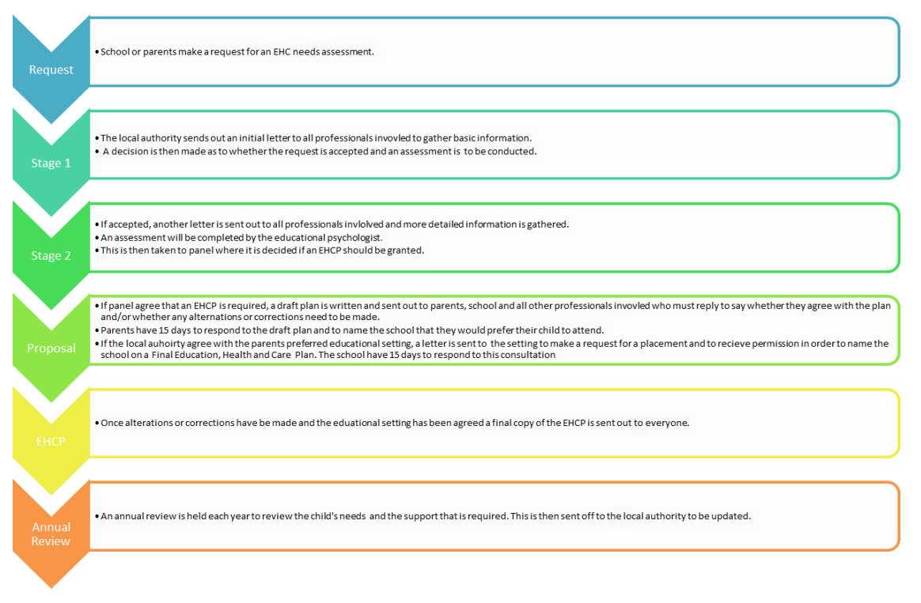
Flowchart to show the Education, Health & Care Plan Process
SEN IEP example

Name |  | Date
DOB |  | Review date
Teacher(s) |  | Reviewed with
Individual Education Plan

Overview
Likes | Dislikes
Strengths | Areas for Improvement

Conditions (verified/unverified)
Diagnosis | Strategies | Review date and notes

Goal setting
SMART goal  Specific, Measurable, Achievable, Realistic, Timely | Strategies  What does the student need to achieve the goal? | Resources  What do we need to implement the strategies? | What went well? | What could be done better?

IEP meeting
Student name |  | Date of meeting
Teacher name |  | Teacher signature
Parent/carer name |  | Parent/carer signature

