WAITING LIST FORM [CONFIDENTIAL]

PUPIL DETAILS
Name:
Date of Birth:
Emergency Contact 1:
Name:
Relationship to child:
Tel Nos:
e-mail:
Emergency Contact 2:
Relationship to child:
Name:
Tel Nos:
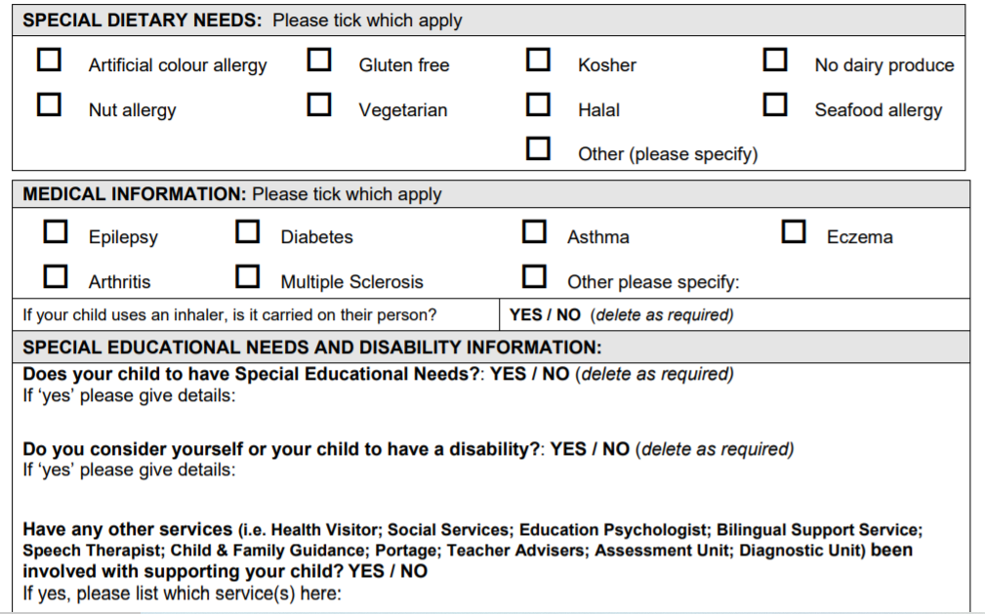

Please check your choices for September:

1 Day ( ) 10.30am – 2.30pm Please specify preferred day …………………..

2 Days ( ) 10.30am – 2.30pm Please specify preferred days ……………………………………………….

3 Days ( ) 10.30am – 2.30pm Please specify preferred days ……………………………………………….

4 Days ( ) 10.30am – 2.30pm Please specify preferred days ……………………………………………….

5 Days ( ) 10.30am – 2.30pm Please specify preferred days ……………………………………………….
We will do our best to accommodate your choices but cannot guarantee days.

Which clubs are you currently interested in? (Please note that these may change before your start date):
Monday: Art ( )
Tuesday: Allotment (gardening) ( )
Wednesday am: Outdoor sports ( )
Wednesday pm: Yoga ( )
Thursday: Music ( )
Friday: Cooking ( )

Signed: __________________________________________ Date: ________________________

